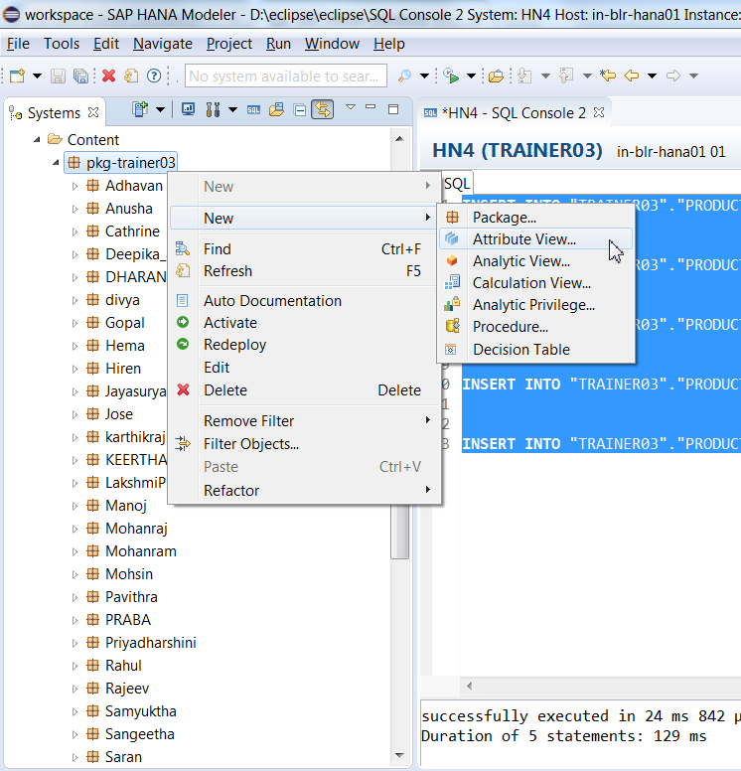

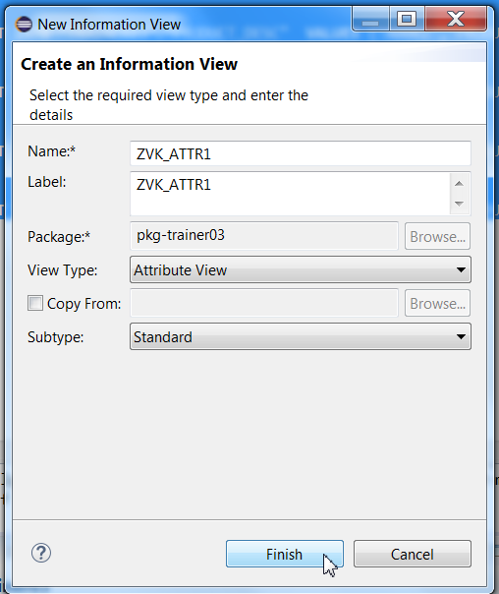

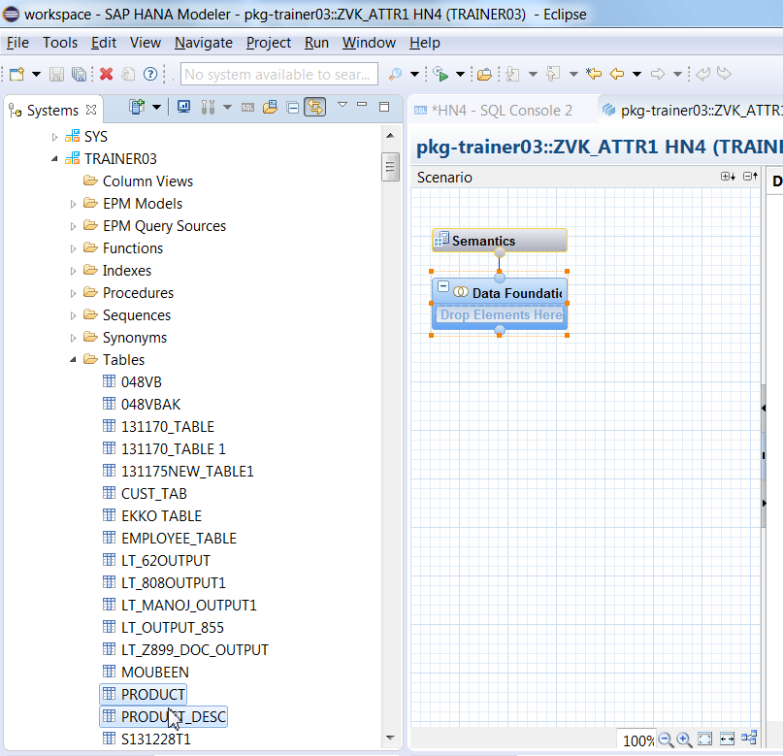

Drag both the tables to data foundation.

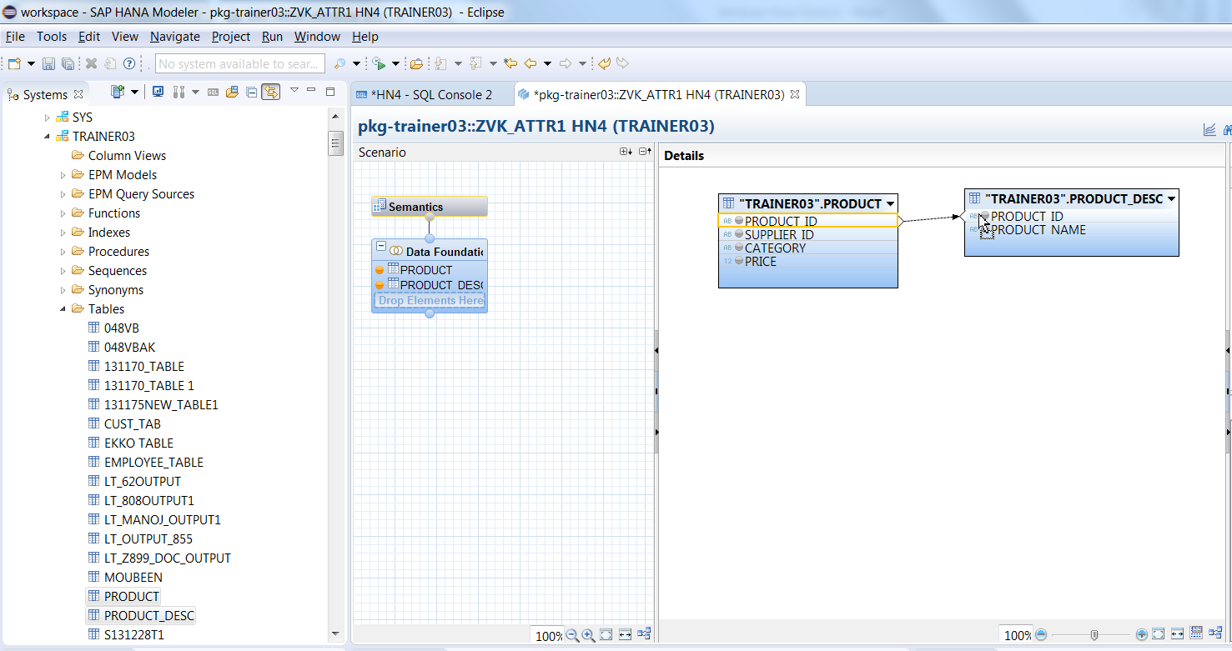

Double click on the connection line to edit the join definition.

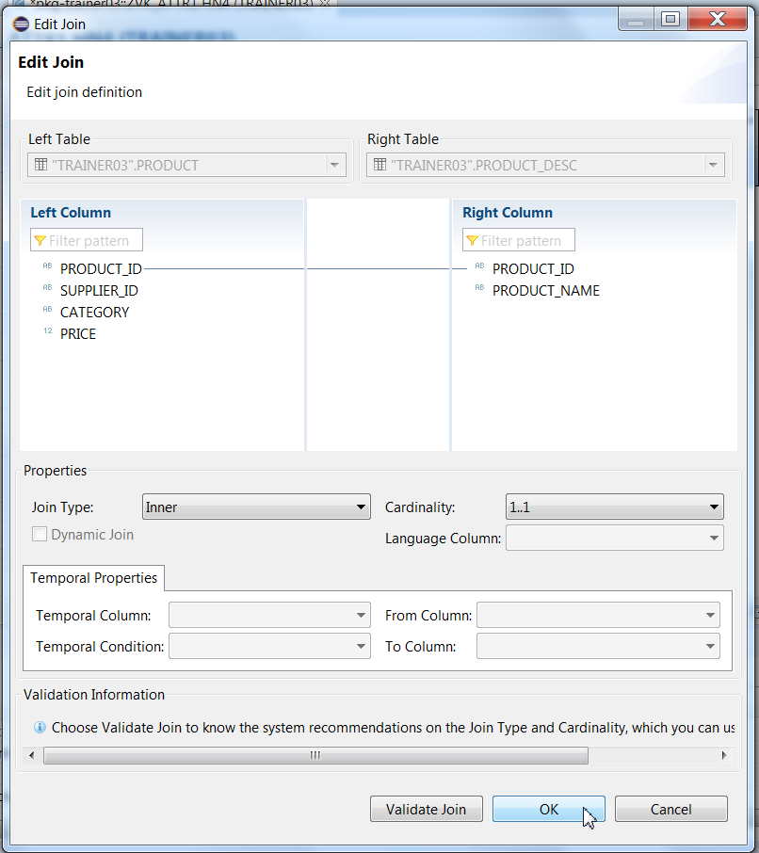

Double Click on Columns to select it. You will see the selected columns on output pane.

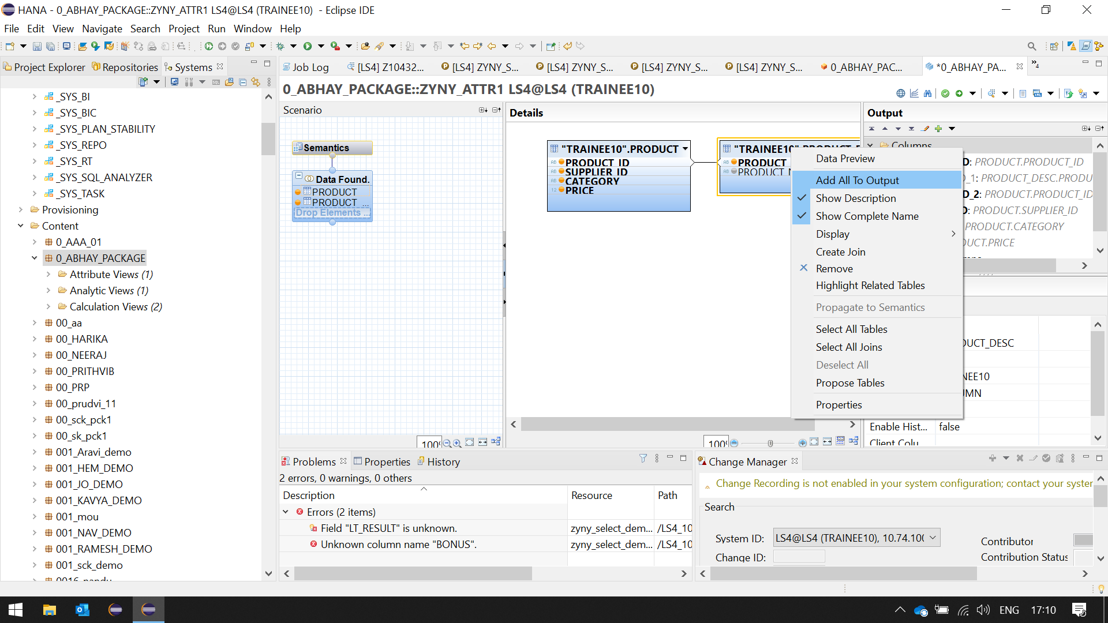

RIGHT CLICK ON THE TABLES AND SELECT ADD ALL TO OUTPUT

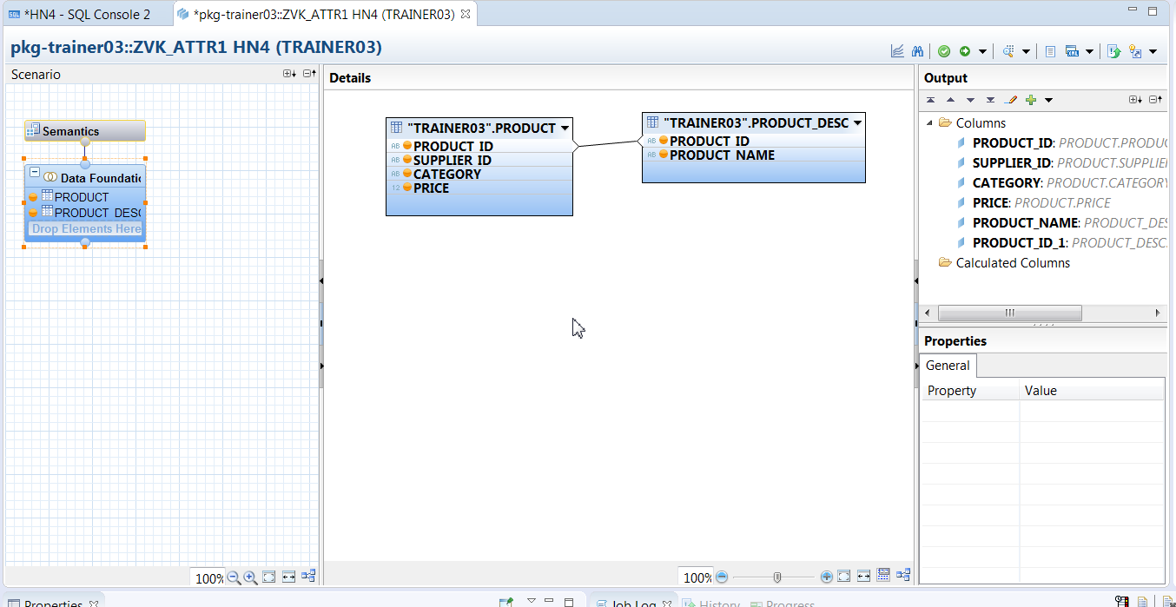

Select Semantics.

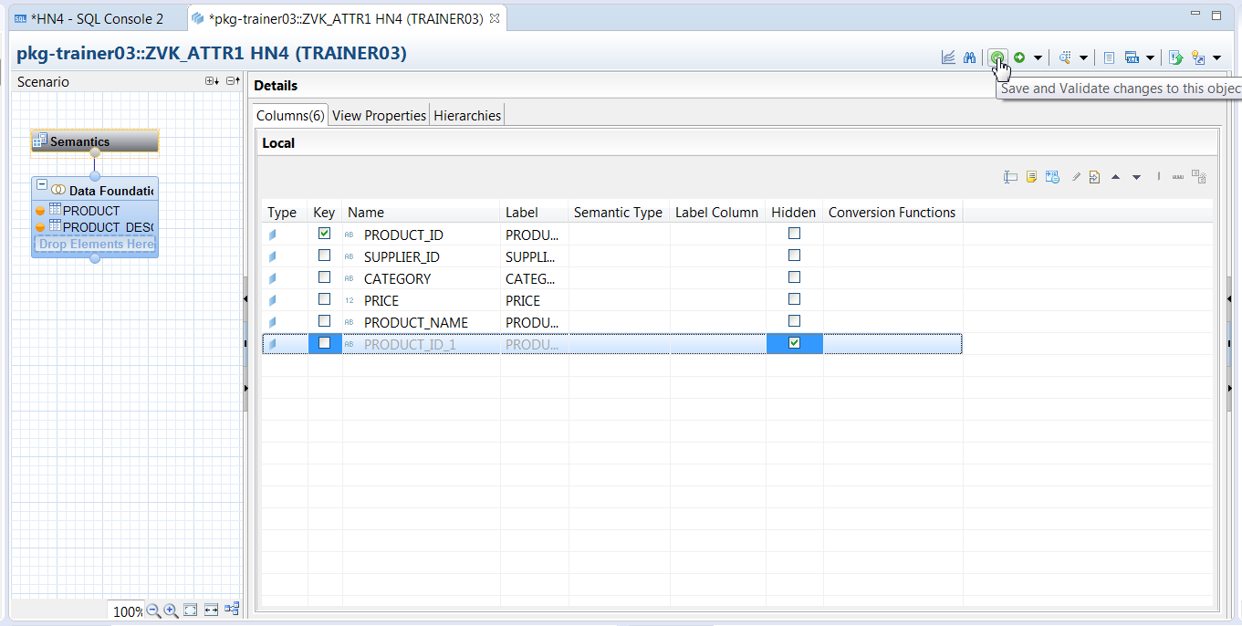

1. Select "PRODUCT_ID" as Key.
2. Check Hidden option for field PRODUCT_ID_1 (PRODUCT_DESC table field).
3. Click on validate Button.
4. After successful validation, click on activate Button.

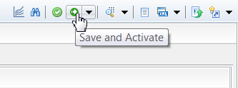

Go to Content-Package- Attribute Views and select the attribute view created. In this case zvk_attr1.

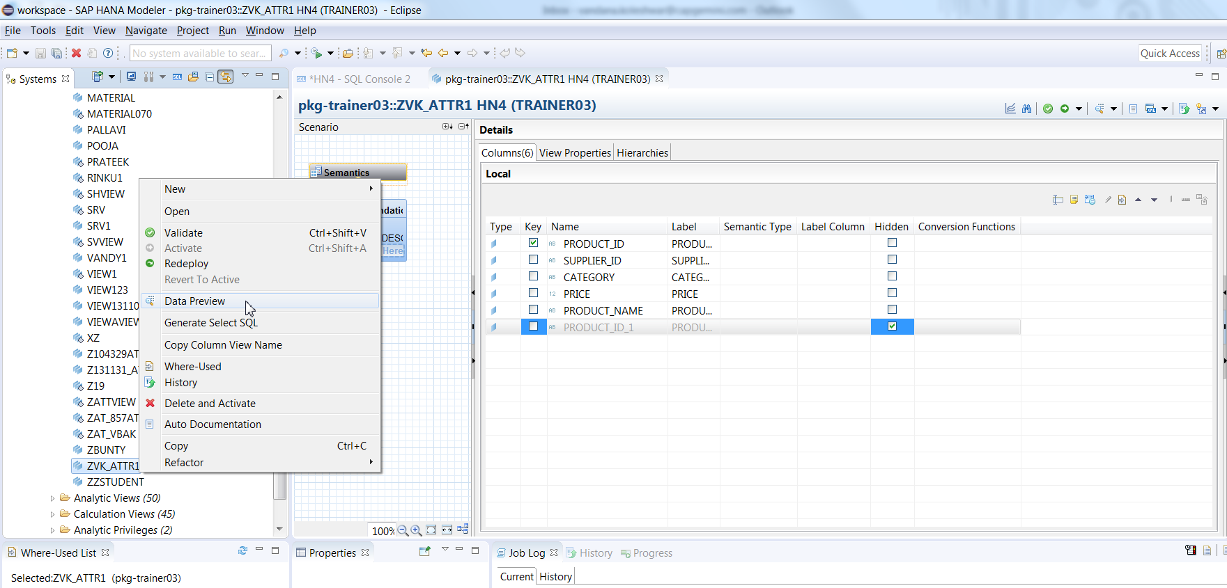

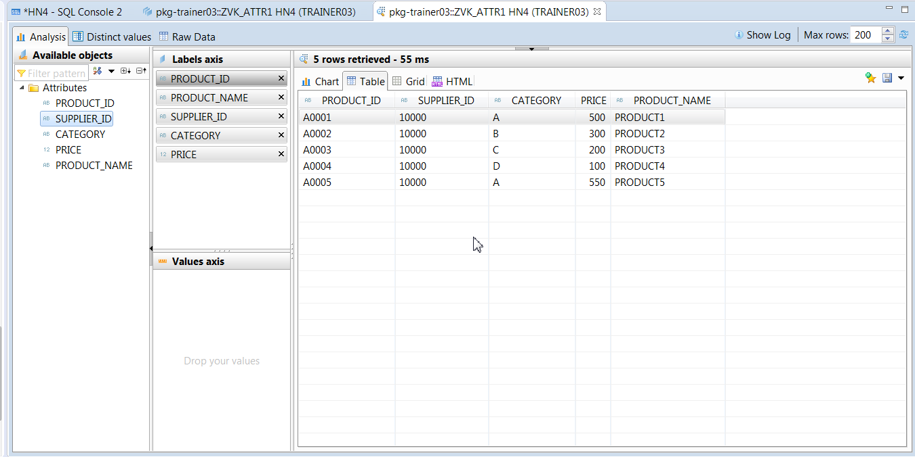

Drag Price from Available Objects Pane to the Value Axis. The chart can be seen only after that.

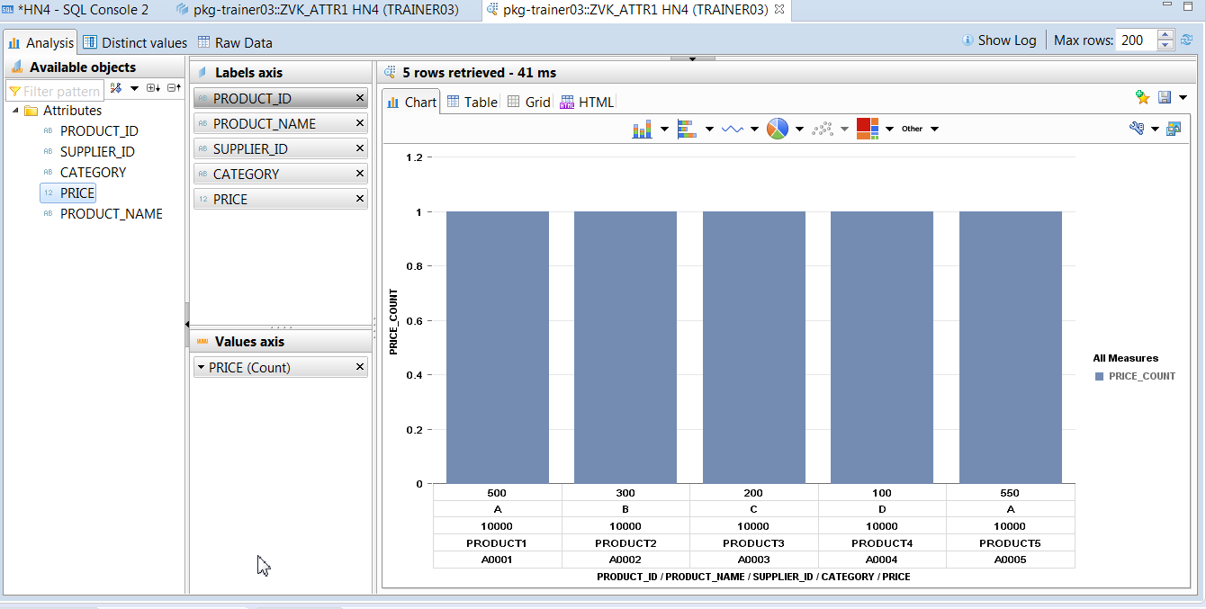

**Distinct Values**: The distinct value of the column can be displayed here. This will show total no. records for selected attribute.

**Raw Data tab:** This option displays data of attribute view in table format.

1. Click on Raw data tab
2. It will display the data in table format

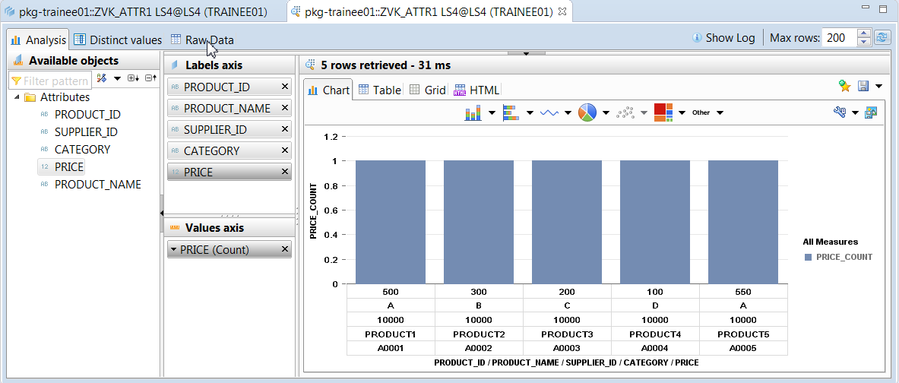

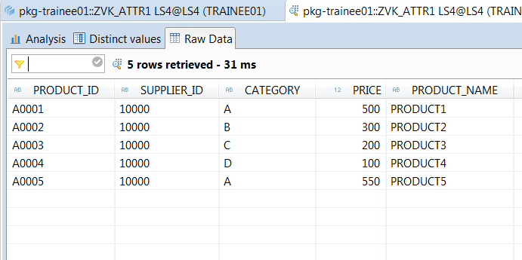

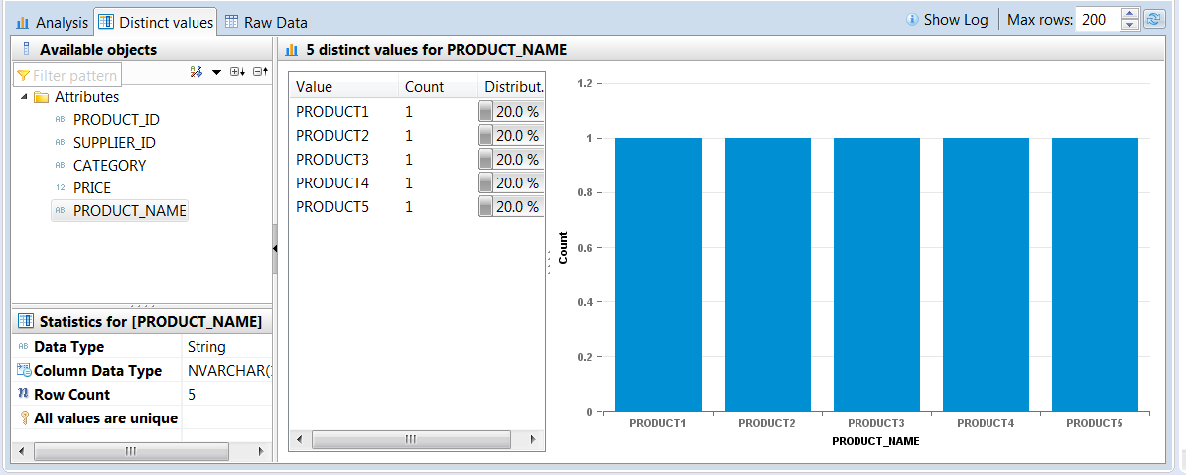

Open in SQL Editor as shown below.

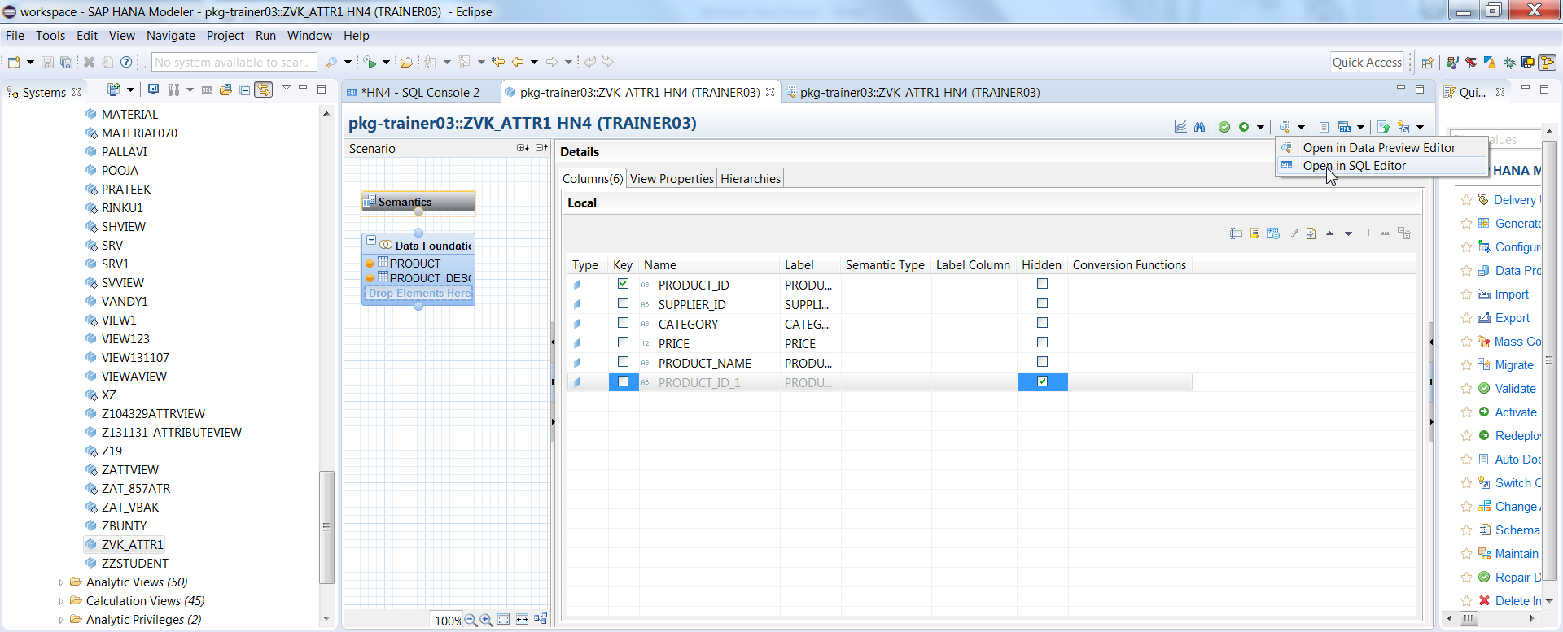

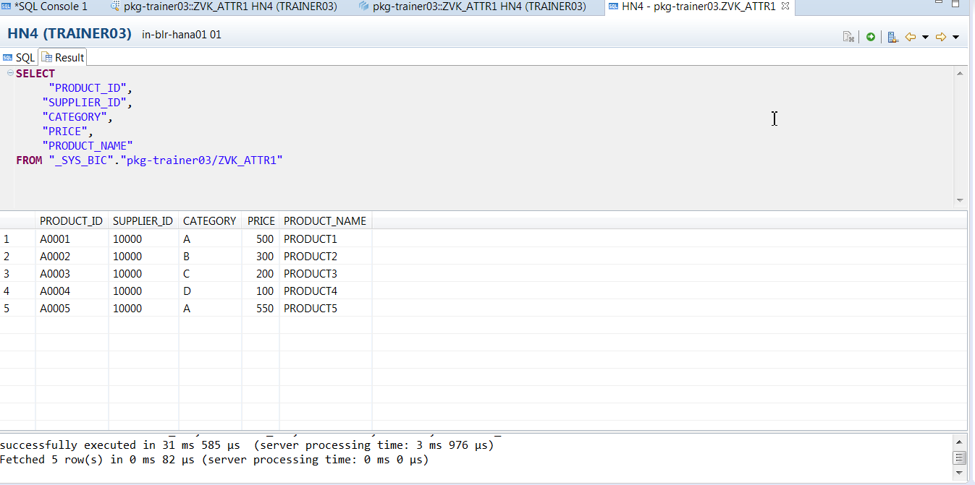

Attribute View when activated, a column view under _SYS_BIC schema is created. So, when we run Data Preview, system selects data from column view under a _SYS_BIC schema.

Screen shot of column view "AT_PRODUCT" under "_SYS_BIC" Schema of catalog node is as below -

